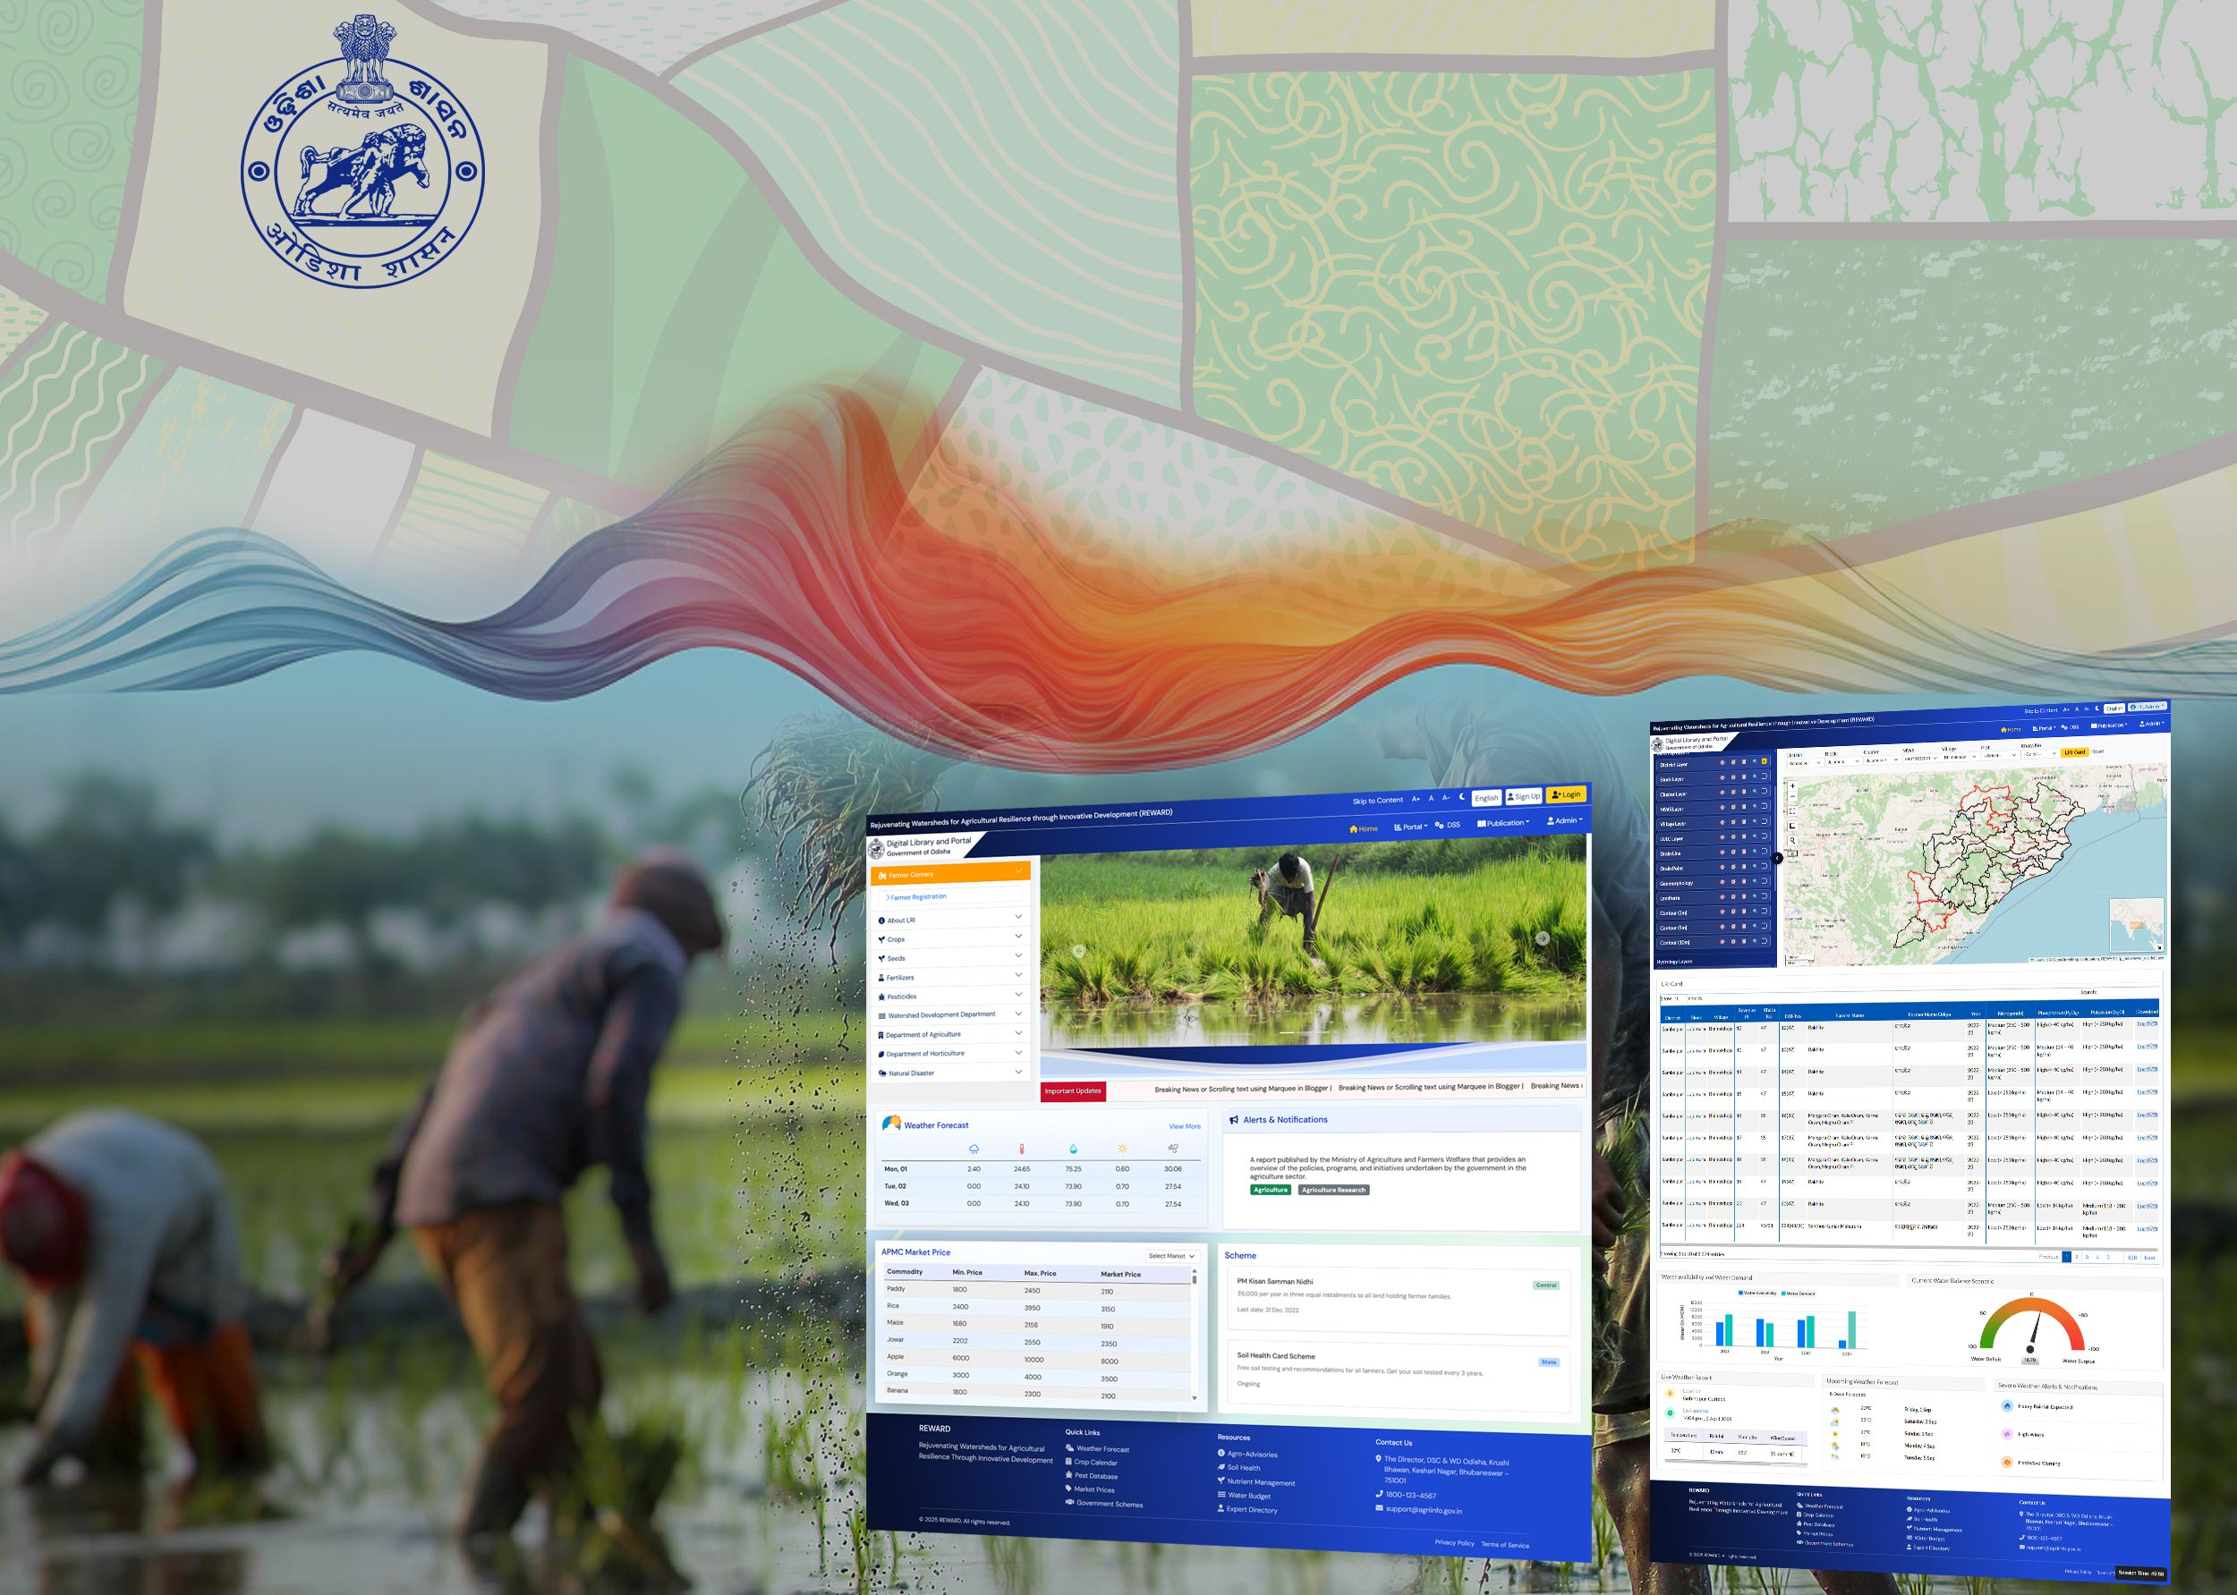
User Manual for Digital Library and Portal

Table of Contents
Introduction 3
Glossary 4
About REWARD 5
Objective 5
Roles & Actions 5
Sign Up 6
Login 7
Administration 10
User Management 11
Add User 11
Edit User 12
Delete User 13
Alert & Notification 14
Add Notificaiton 14
Edit Notification 16
Delete Notification 17
View Notification 17
Digital Library 18
Upload File 18
View Added Data 21
REWARD Portal 23
LRI Card 24
Map Viewer 26
Tool Used in LRI MAP 26
Basemap Switcher 27
Cluster Filter & Feature Info 28
Attribute Viewer 29
View Legend 30
Layer Visibility 31
Zoom to Layer & Default Extent 32
Style Manager 34
Measurement Tool 38
Search Location 40
Full Screen 41
Dashboard 43

Introduction

Glossary
S. No | Term | Description
1 | REWARD | Rejuvenating Watersheds for Agricultural Resilience through Innovative Development
2 | AOI | Area of Interest
3 | APMC | Agricultural Produce & Livestock Market Committee
4 | AWS | Automatic Weather Station
5 | DL | Digital Library
6 | DSS | Decision Support System
7 | ET | Evapotranspiration
8 | GIS | Geographic Information System
9 | GWD | Ground Water Development
10 | HEC-HMS | Hydrologic Modelling System
11 | LRI | Land Resource Inventory
12 | MWS | Micro-Watershed
13 | NBSS & LUP | National Bureau of Soil Survey & Land Use Planning
14 | OCAC | Odisha Computer Application Centre
15 | OUAT | Odisha University of Agriculture & Technology
16 | PET | Potential Evapotranspiration
17 | SWAT | Soil and Water Assessment Tool
18 | TMU | Thematic Mapping Unit

About REWARD
The REWARD–Odisha Digital Library & Decision Support Portal is a centralized platform designed to support science-based watershed management and climate-resilient agriculture. It integrates spatial and non-spatial datasets related to Land Resource Inventory (LRI), hydrology, land use, climate, and crop suitability, enabling stakeholders—including DSC&WD, technical partners, and farmers—to access, analyse, and utilize parcel-level information. With GIS-enabled visualization, automated DPR generation, LRI cards, and dynamic agro-advisories, the system strengthens planning, monitoring, and decision-making at village and micro-watershed levels.
Key benefits of REWARD:
- Centralize and efficiently manage LRI, hydrology, and agro-advisory datasets.
- Enable informed decision-making through GIS-based visualization and analysis.
- Integrate DSS modules for LRI cards, crop suitability, agro-advisories, and automated DPRs.
- Support efficient planning, monitoring, and implementation of watershed interventions.
- Provide intuitive, role-based access for administrators, technical users, field staff, and farmers.
- Promote climate-resilient and science-based agricultural practices.
- Enhance collaboration and knowledge-sharing across departments and partners.
- Strengthen transparency and accountability through data-driven monitoring tools.

Objective
The objective of this document is to define the purpose and use of the Digital Library & Decision Support Portal developed under the REWARD–Odisha Programme.
It explains how the system centralizes spatial and non-spatial datasets, streamlines data access, enables GIS-based visualization, supports automated generation of agro-advisories, LRI cards, and DPRs, and enhances decision-making for watershed management.
This document provides stakeholders with the necessary information to understand the system’s functionalities, workflows, user roles, and operational processes for effective utilization.

Roles & Actions
SL No. | Roles | Step Description
1 | Farmers | Accessing real-time agricultural advisories, weather updates, crop suggestions, and market prices.
2 | Government Officials/Line Departments | Utilizing spatial and non-spatial data for planning and policy-making related to watershed management, water conservation, and other related fields.
3 | Researchers and Experts | Accessing detailed hydrology, land resources, and agricultural datasets for research and development.
4 | Administrators | Full access to all functionalities, including user management and system configuration.
5 | Project Partners | Access for data migration and uploading to the portal by log in credentials.
6 | Data Managers | Access to data management and integration tools.
7 | Public Users | Access to public information and educational resources but only in readable format and non-editable mode.

Sign Up
Sign-Up functionality allows new users to register for the system. Once the sign-up request is submitted, it is sent to the system administrator for approval. After the administrator approves the request, the newly created user can log in to the application.
To sign up:
- To access REWARD application, go to browser and enter <URL>.
- Click on ‘Sign Up’ button.
- System opens a signup page with Name, Email, Phone Number, Role, Username, Password etc.
- Fill all the required details.
- Select Role, enter username and password.
- Click on ‘Sign Up’ button to submit the request.
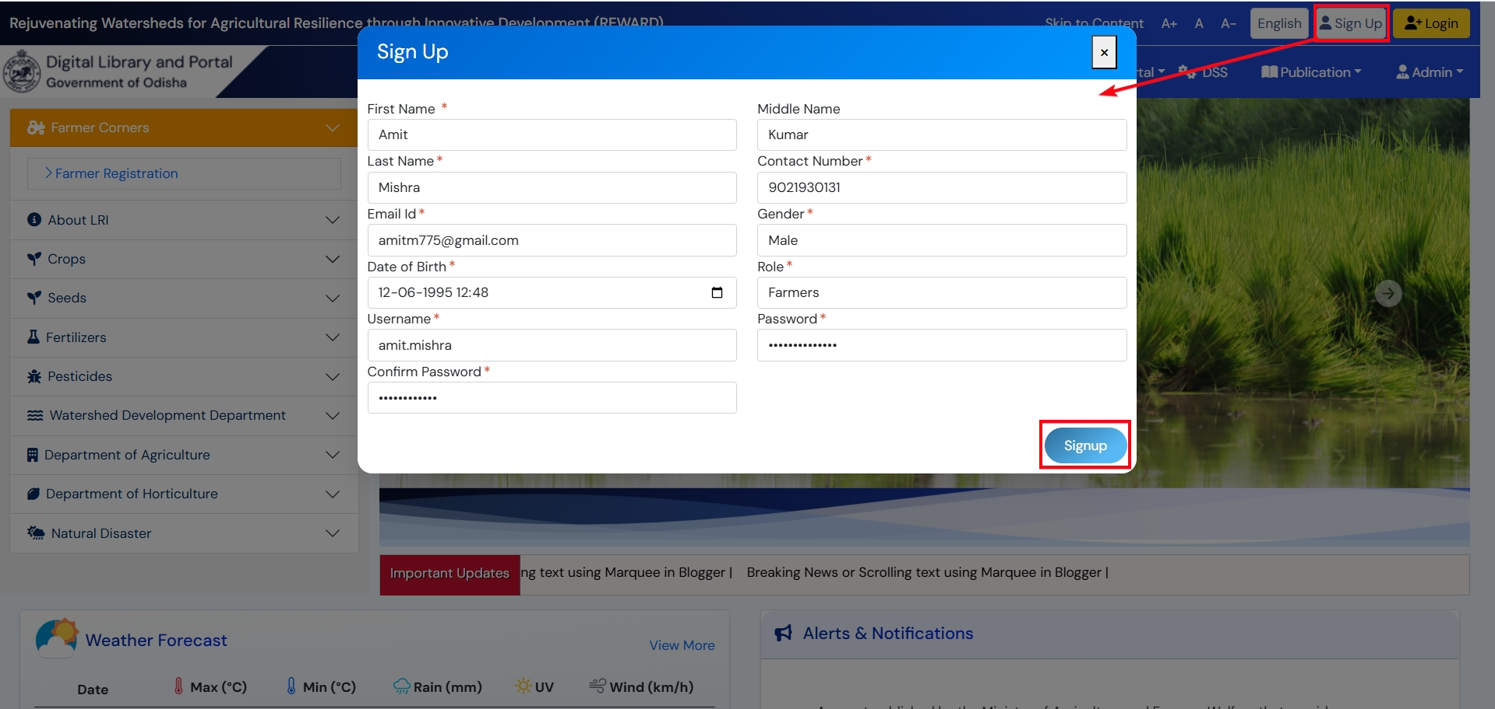
Figure 1: Sign Up

Login
- To access REWARD application, go to browser and enter <URL>.
- Click on ‘Login’ button, login pop-up will appear.
- Enter ‘Username’ , ‘Password’ and click on ‘Login’ button.
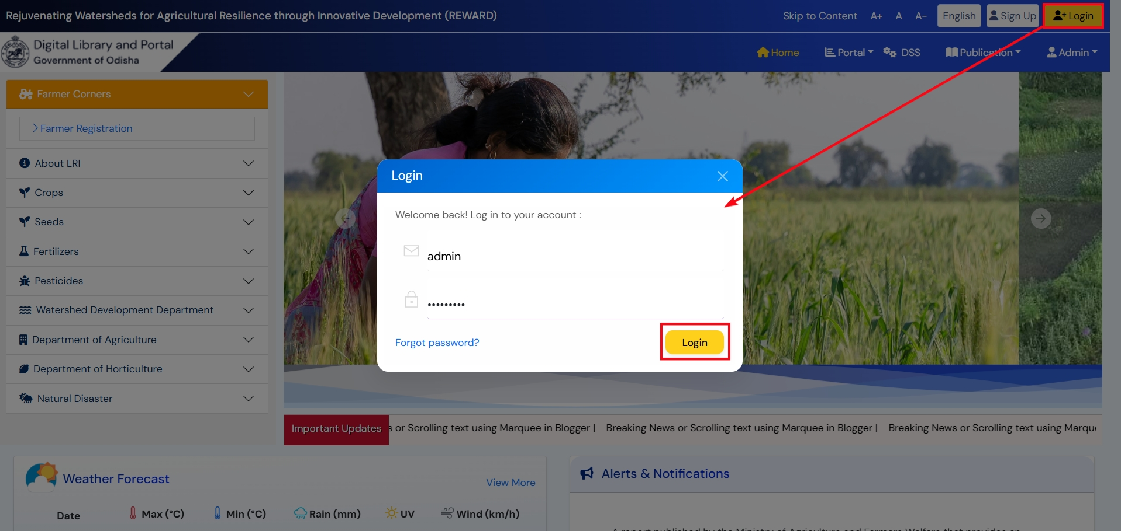
Figure 2: Login to application
- On successful authentication, application will take the user to homepage of the application.

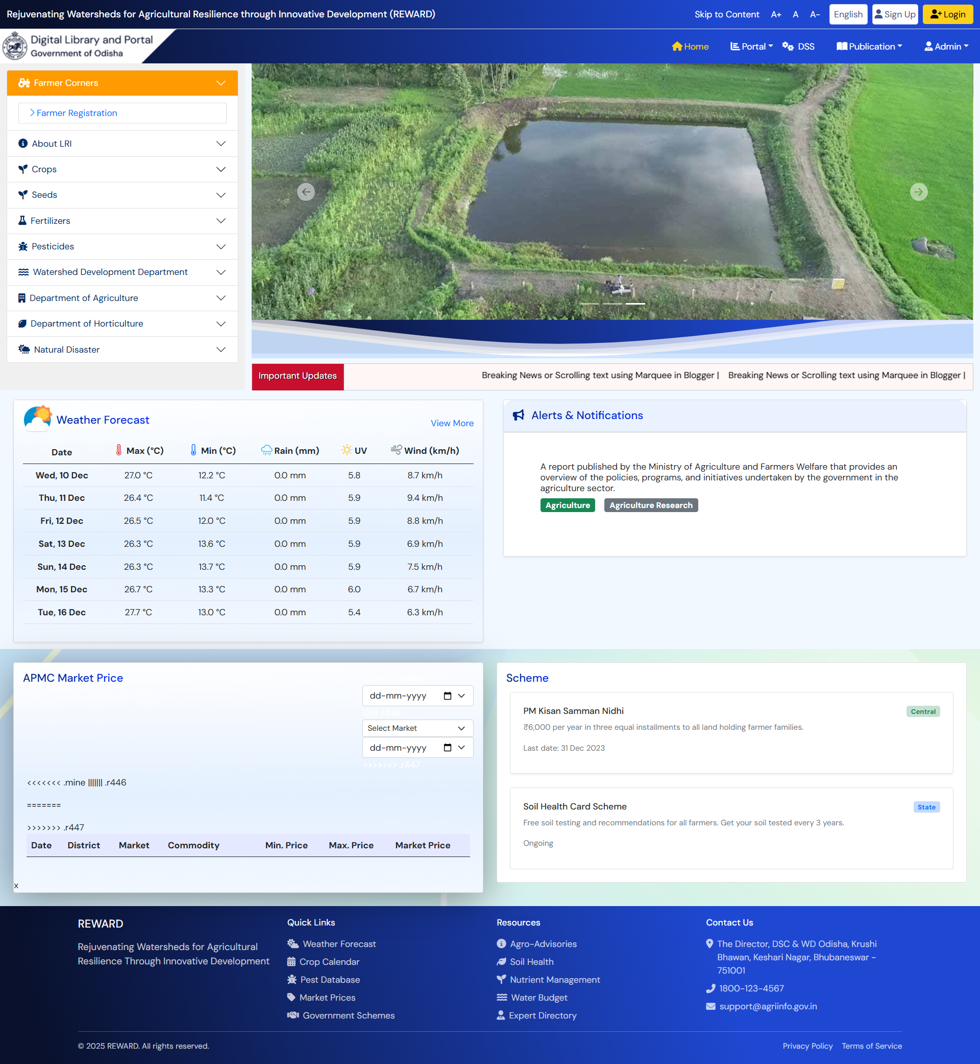
Figure 3: Landing Page

Administration
(Admin User)

The Admin Module provides control over user management and file handling within the application. Through this module, an admin user can create, edit, or delete both new and existing user accounts to ensure proper access and role management across the system.
In addition, the admin can manage Alerts & Notifications that appear on the application’s homepage, including adding new messages, updating existing ones, or removing outdated information. The module also enables admins to oversee file uploads, such as cluster files and other supported formats like DOC, PDF, and more, ensuring that all necessary documents are available and properly organized within the system.

User Management
User Management provides authorized administrators with full control over managing user accounts within the system. This includes creating new users, updating details of existing users, and removing users who no longer require access. The module ensures that the right individuals have the appropriate permissions and roles, supporting secure and efficient system access.

Add User
To add User, follow below steps:
- Go to Admin Add User.
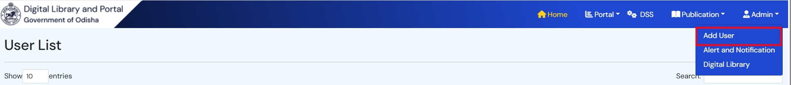
- Click on ‘NEW USER’ button.
- Fill User details like First Name, Middle Name, Last Name and Contact Number.
- Enter Email ID, District, Gender, Role, Username, Password and Confirm Password.
- Select Module and related Sub-Module and click on ‘SUBMIT’ button.
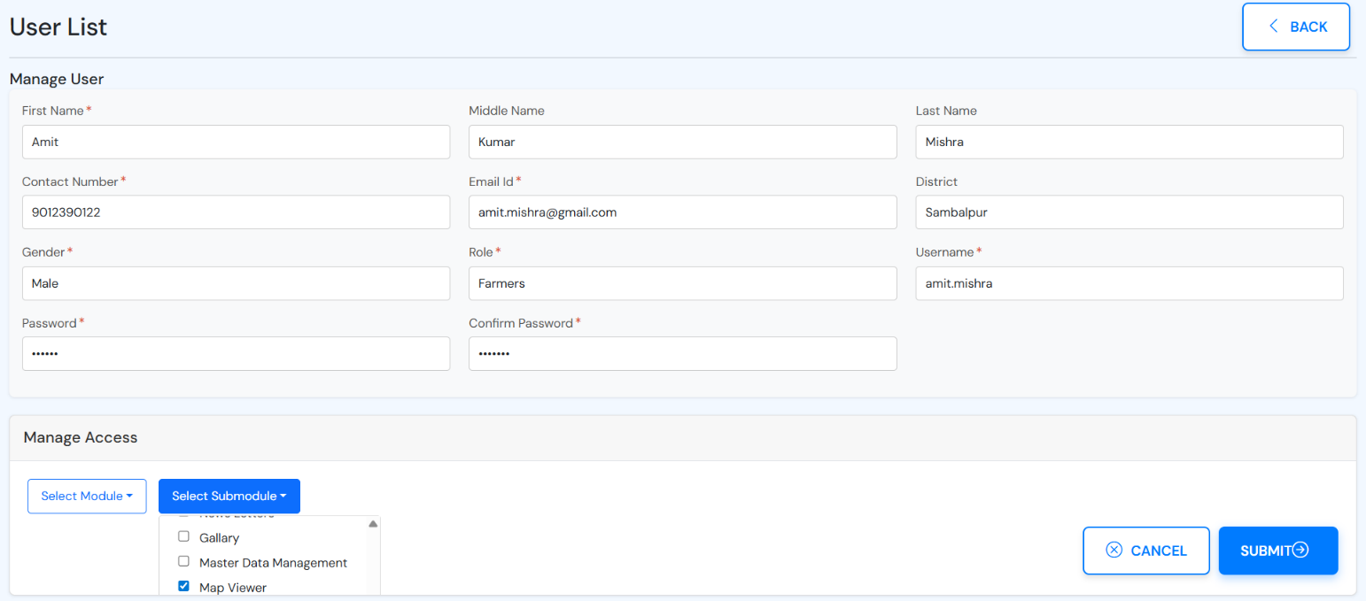
Figure 4: Add User Screen

Edit User
To edit User, follow below steps:
- Go to Admin Add User.
- Enter username in search box and click on ‘Edit’ icon for searched record.
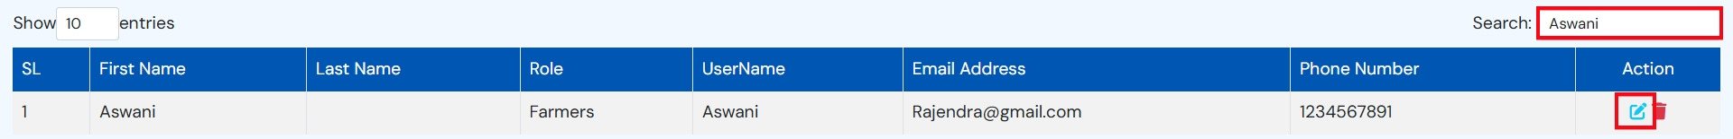
- Edit allowed fields.
- Edit Module and related Sub-Module and click on ‘SUBMIT’ button.
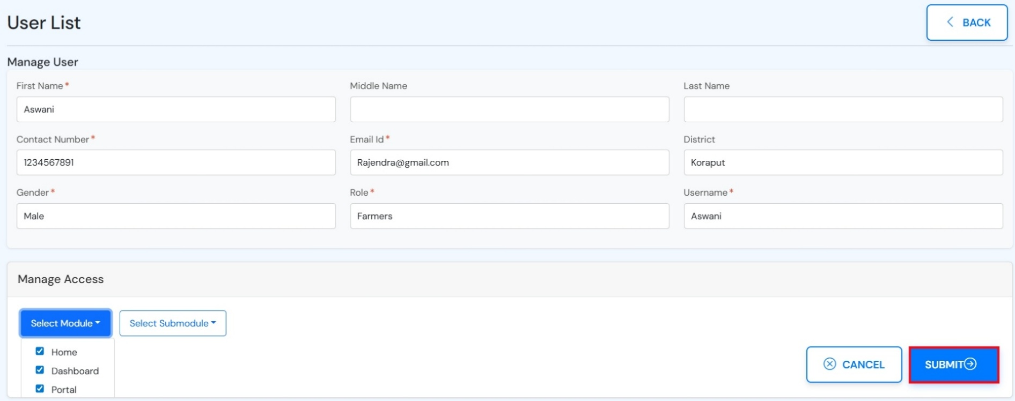
Figure 5: Edit User

Delete User
To delete User, follow below steps:
- Go to Admin Add User.
- Enter username in search box and click on ‘Delete’ icon for searched record.
- Application will open a pop-up with OK and Cancel buttons.
- Click on ‘OK’ button to delete a user from the system.
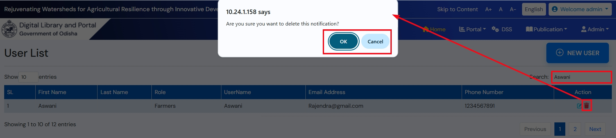
Figure 6: Delete a user

Alert & Notification
Alert & Notification allows authorized users to create, update, and delete alerts and notifications displayed within the system. Through this module, users can manage important announcements, updates, and messages that appear on the homepage or other designated sections, ensuring timely communication and visibility of critical information.

Add Notificaiton
To add notification, follow below steps:
- Go to Admin Alert & Notification.
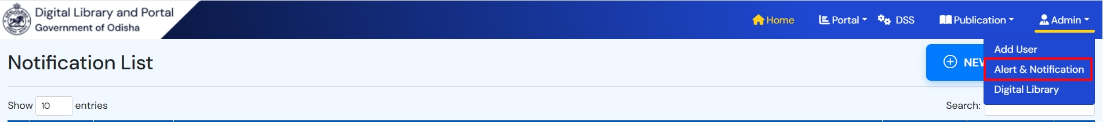
- Enter title, choose Notification Type, Start and End Date, enter message.
- Click on ‘SUBMIT’ button.
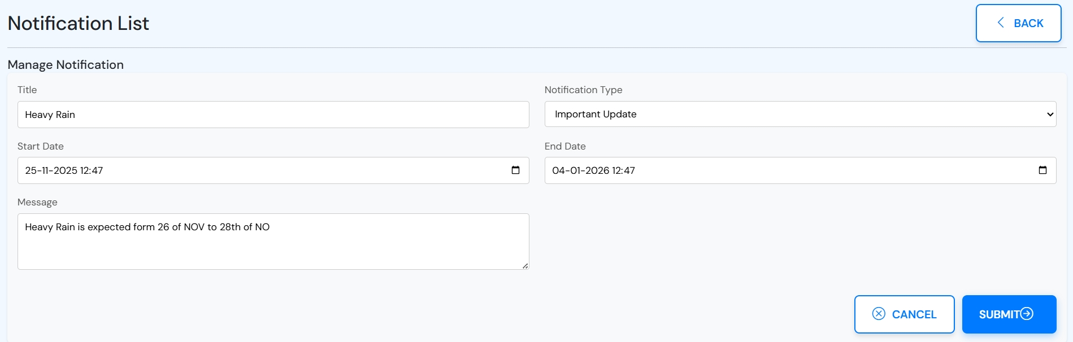
Figure 7: Submit Notification
- If Notification Type is ‘Important Update’, it will be visible in banner section of the homepage and if ‘Alert & Notification’ is chosen, it will be shown in Alert section in homepage.

Edit Notification
To edit notification, follow below steps:
- Go to Admin Alert & Notification.
- Enter notification title in search box and click on ‘Edit’ icon for searched record.
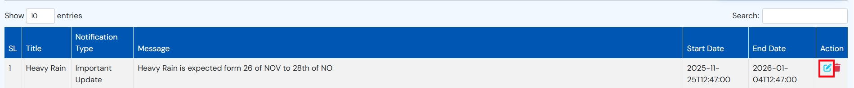
- Edit allowed fields and click on ‘SUBMIT’ button.
Figure 8: Edit Notification

Delete Notification
To delete notification, follow below steps:
- Go to Admin Alert & Notification.
- Enter username in search box and click on ‘Delete’ icon for searched record.
- Application will open a pop-up with OK and Cancel buttons.
- Click on ‘OK’ button to delete a notification from the system.
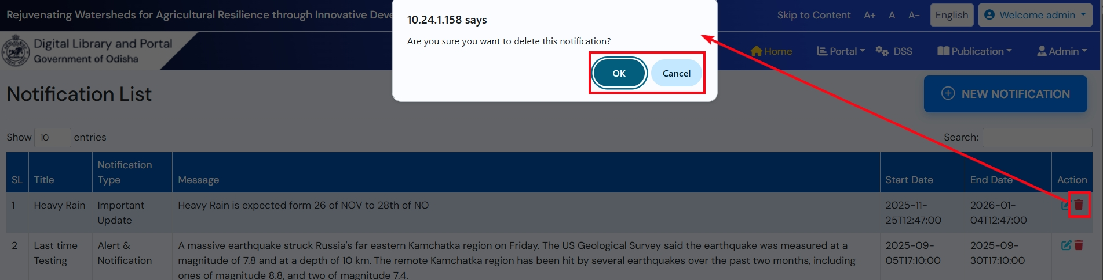
Figure 9: Delete Notification

View Notification
To View added notifications, follow below steps:
- Go to “Important Updates” and “Alerts & Notifications” section from homepage.
- View the notification that are within the current date frame.

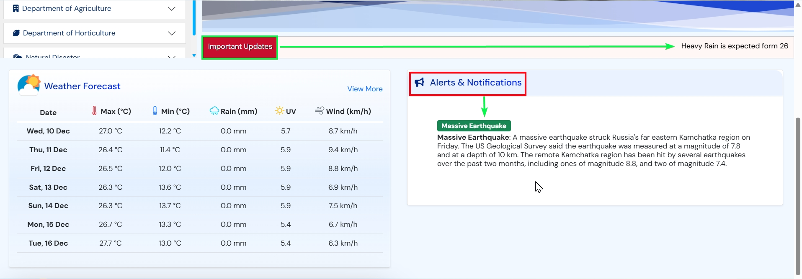
Figure 10: View Notification

Digital Library
Digital Library enables administrators to upload shapefiles for waterbody clusters as well as other important documents required for the system, such as reports, reference files, and supporting datasets. This module also provides an organized interface to view all uploaded datasets and documents. Users can easily access and download these files as needed, ensuring smooth data sharing and centralized information management.

Upload File
To upload files, follow below steps:
- Go to Admin Digital Library.
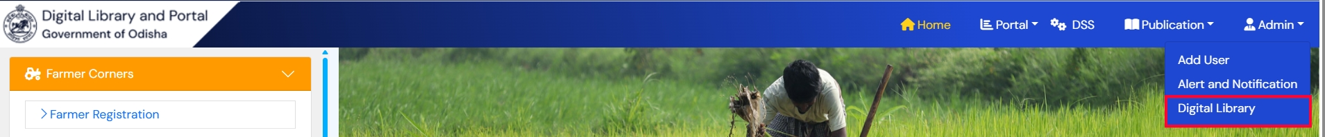
- Click on ‘Data Upload’ button.
- Choose ‘Upload Layer Shape File’ or ‘Upload Other Files’.
- Choose Cluster Name from dropdown and click on ‘Browse’ button.
- System will ask to confirm the upload, accept it by clicking ‘Upload’ button.
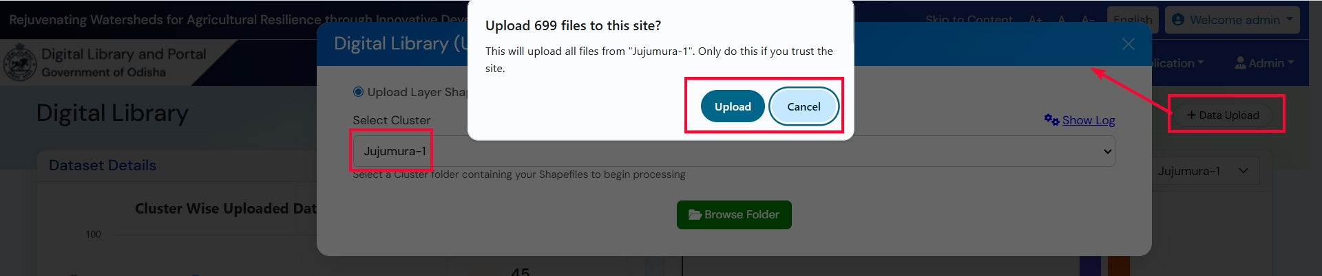
Figure 11: Folder Upload
- System will check the validity of the folder, if all goes well it will open a pop-up with success alert.

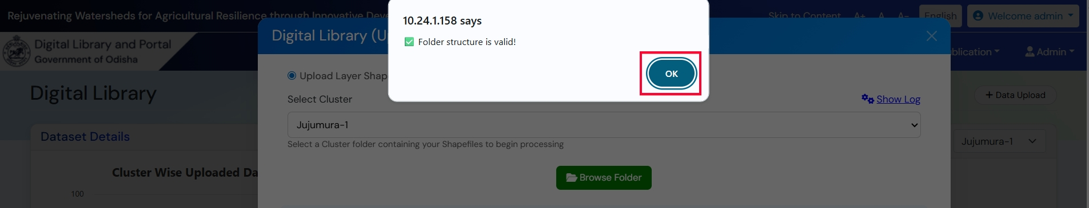
Figure 12:Folder Validity
- System will append the summary of uploaded cluster with checkboxes to select along with ‘Select All’, ‘Deselect All’ and ‘Process Selected Files’ buttons.
- Select /Deselect desired files and click on ‘Process Selected Files’.
- On successful process, added data will be visible under ‘Recently Added Datasets’ section and also in ‘Map Viewer’ section under Portal module.
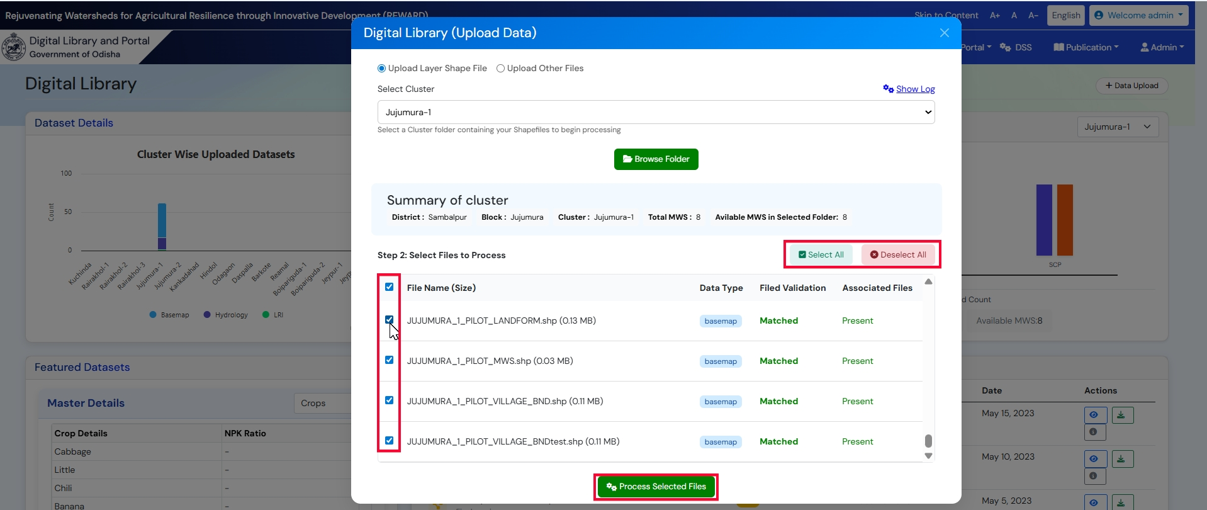
Figure 13: Process Files

View Added Data
To view added data, go to Admin Digital Library and view/download the data under ‘Recently Added Datasets’.
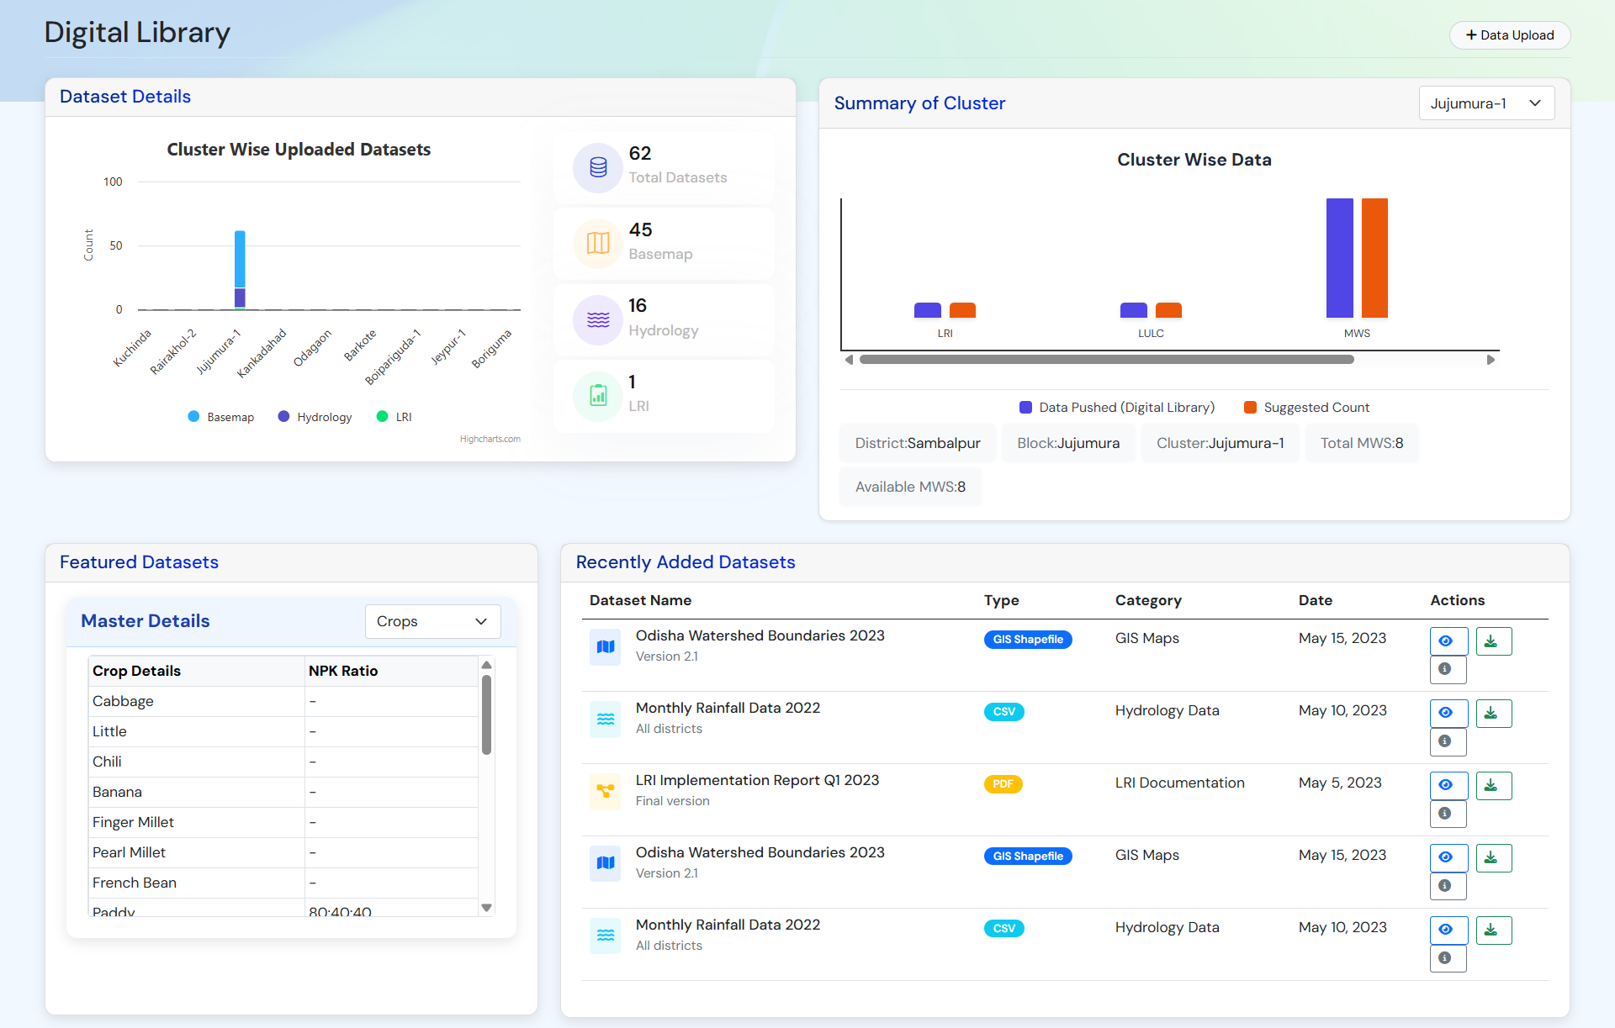
Figure 14: View Uploaded Data

REWARD Portal
(Admin User, Data Manager & Farmer)

The Portal Module allows users to view cluster data and land/plot details through an interactive map viewer. It offers clear, user-friendly visualization of spatial information. Users or farmers can also download their LRI Card (English or Odia) directly from the portal.

LRI Card
LRI Card is a scientific report given to farmers that contains detailed information about their soil and land, such as soil type, fertility, nutrient status, and crop suitability. It is to help farmers make better decisions on which crops to grow and how to use fertilizers and water more effectively, ultimately improving productivity and soil health.
To download LRI Card, follow below steps:
- Go to Portal LRI Card.
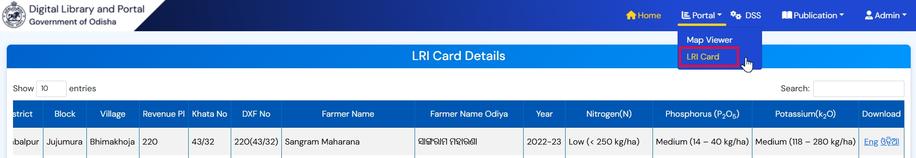
Figure 15: LRD Card Section
- Search the farmer’s name in search box.
- Click on ‘Eng’ / ‘ଓଡ଼ିଆ’ link.
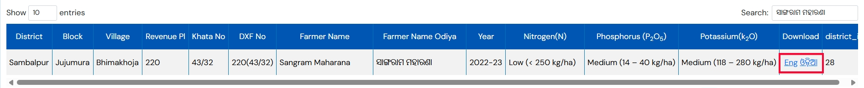
Figure 16: Download Link
- System should open LRI Card in a new window with ‘Download PDF’ button.
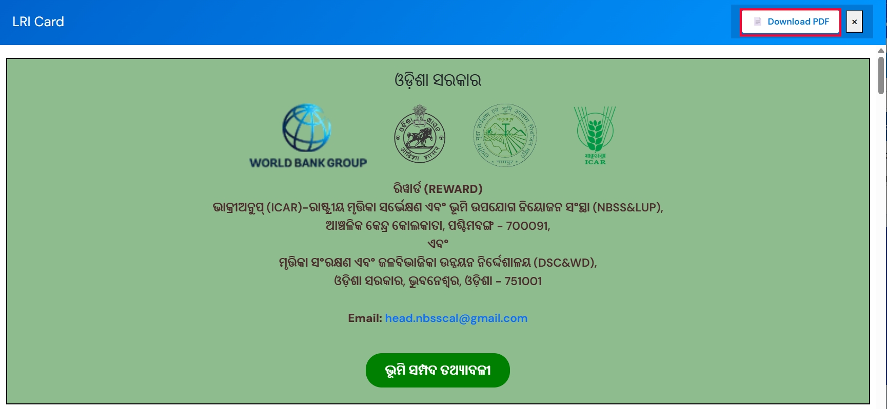
Figure 17: Download Card

Map Viewer
The LRI Maps module provides interactive, cadastral-level visualization of land resource information, including soil properties, slope, land use, nutrient status, and land capability. It allows users to select any area of interest and explore detailed thematic layers that support planning, agro-advisory services, and watershed development activities. To view details on map, Go to Portal Map Viewer.

Tool Used in LRI MAP
- Basemap Switcher : To switch the basemap between Open Street Map and Satellite.
- Layer Manager: User can perform following action under layer manager
- To on/off any layer by the checkbox present on the layer.
- To change the color and width of the layer by ‘Style Manager’.
- To view the legend of the layer.
- To manage style of the layer.
- To view the attribute of the layer.
- To zoom to selected layer.
- Zoom In/Zoom Out : To Zoom in or zoom out from the map.
- Full Screen: To apply full screen for the map.
- Measurement Tool: To measure the area in and perimeter on the map.
- Search Location: To search any place on the map.
- Default Extent: To Return to maps default zoom label.
- Feature Info: To View the metadata about selected/filtered layers.
- Cluster Filter: To filter and view the cluster/plot details on the map.

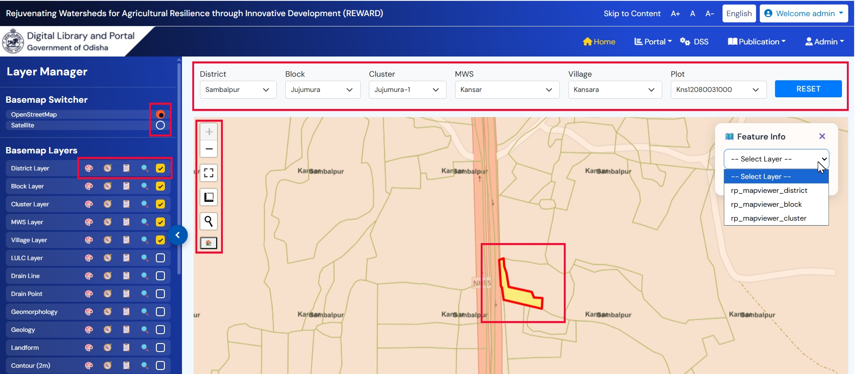
Figure 18: LRI Map Viewer

Basemap Switcher
To switch basemap :
- Click on ‘Open Street Map’ or ‘Satellite’.
- Selected basemap will be loaded on the map viewer.

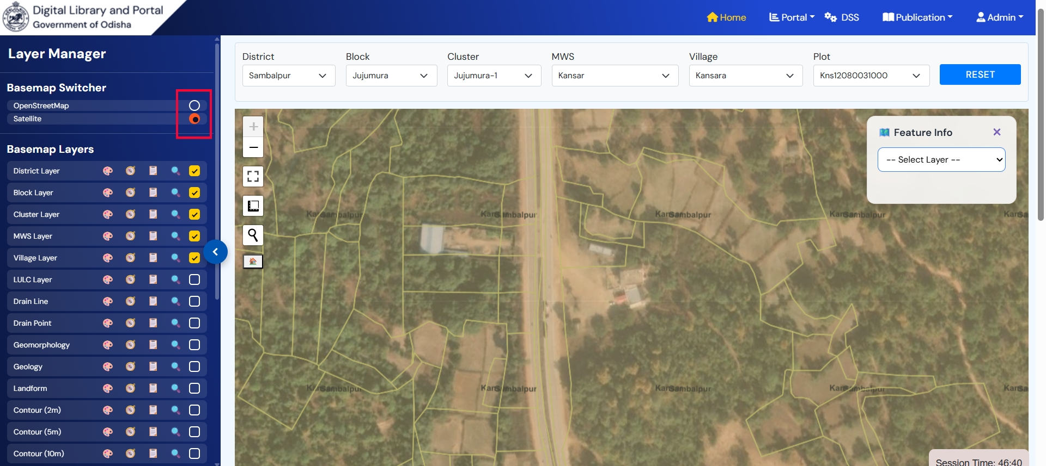
Figure 19: Basemap Switcher

Cluster Filter & Feature Info
To filter data/plot :
- Select District, Block, Cluster, MWS, Village and Plot.
- Selected Plot or Village will be highlighted on the map.
- Filtered layers will be loaded on the ‘Feature Info’ dropdown.
- Select any layer and view the metadata of the selected layer.
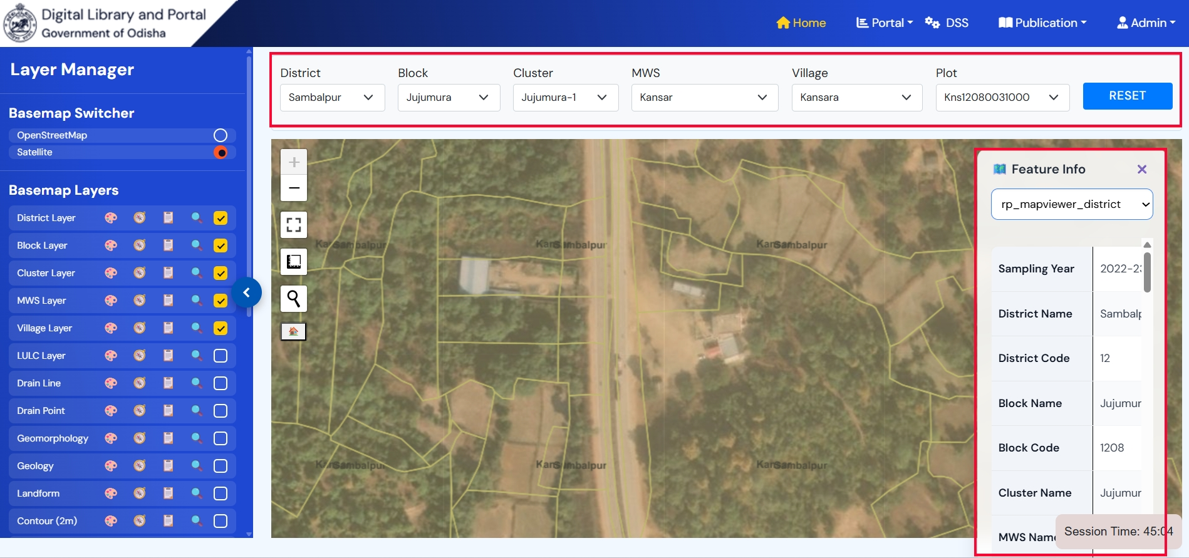
Figure 20: Filter and View Feature Information

Attribute Viewer
To view attribute :
- Click on ‘Attribute Table’ tool from any layer.
- View the attribute in tabular form.
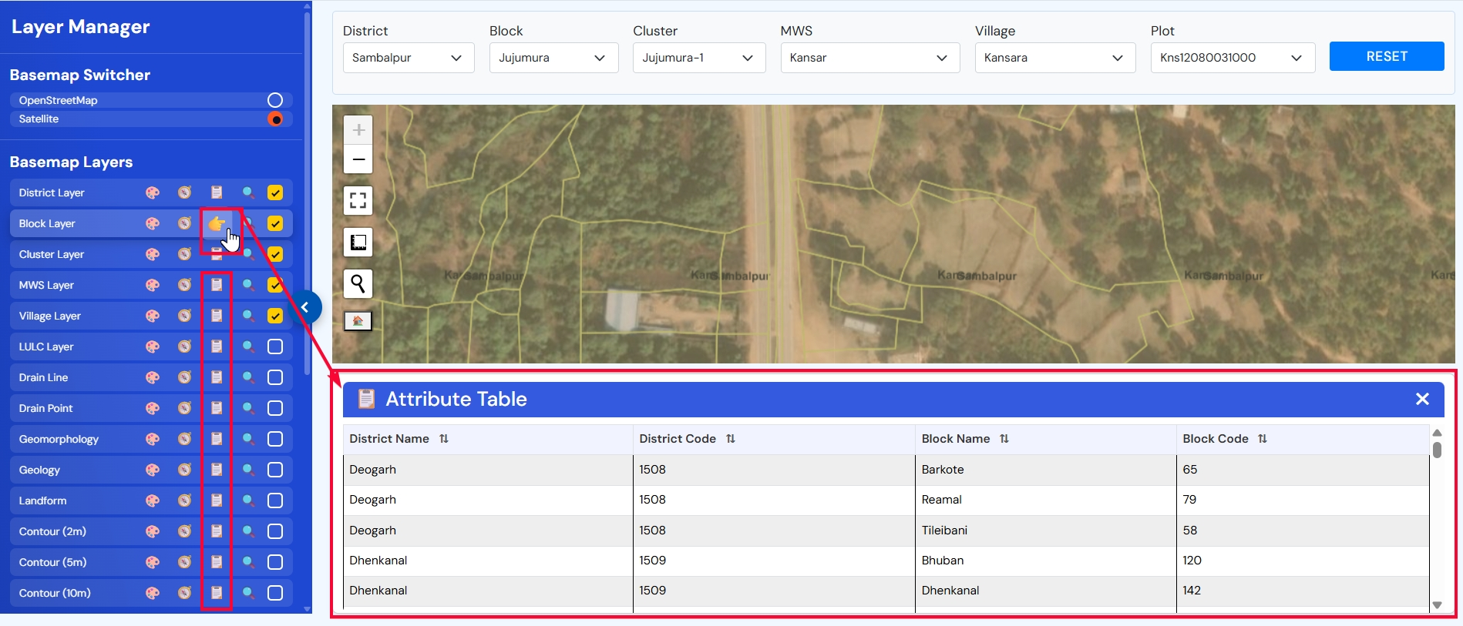
Figure 21: View Attribute

View Legend
To view legend :
- Click on ‘Show Legend’ tool from any layer.
- Application will open a pop-up with name and color used in legends for the selected layer.
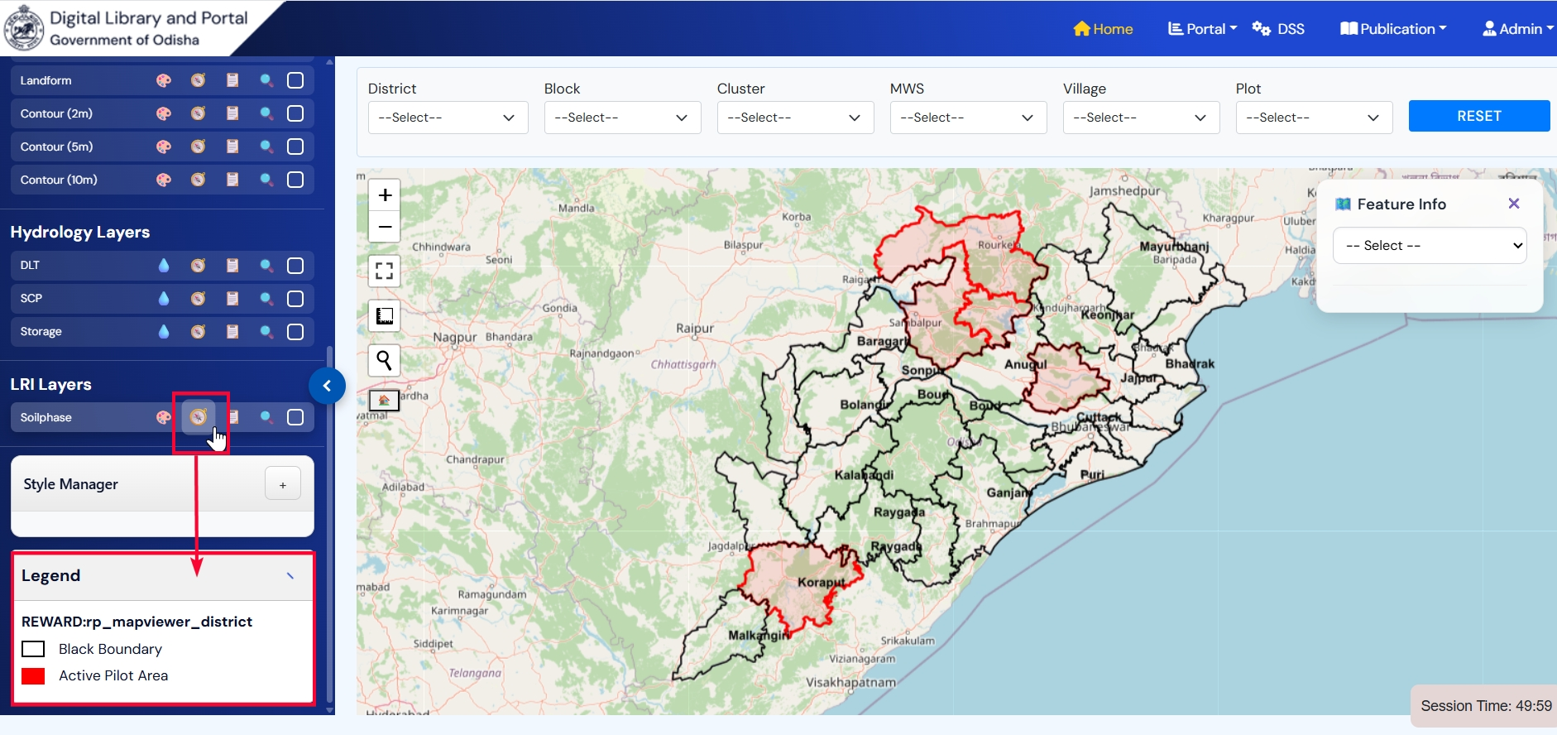
Figure 22: View Legend

Layer Visibility
To On/Off any layer :
- Click on ‘Visibility’ checkbox for the layer if unchecked to view the layer on the map.
- Similarly uncheck the checkbox to off the visibility of the selected layer.
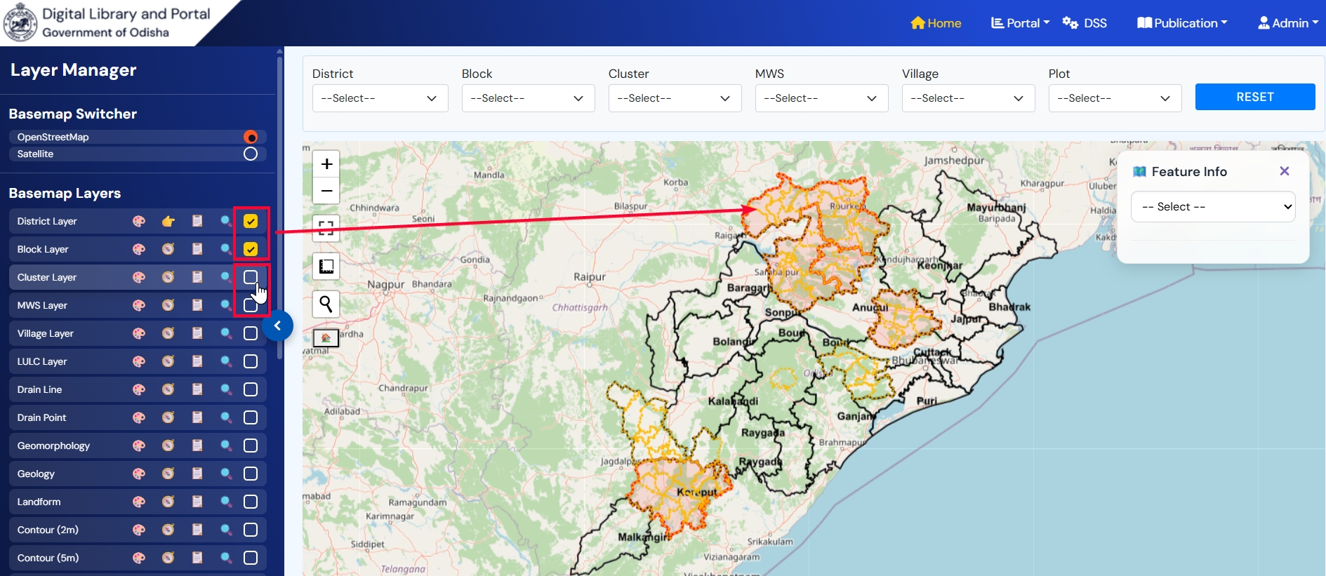
Figure 23: Layer Visibility

Zoom to Layer & Default Extent
To zoom to selected layer:
- Click on ‘Zoom to Layer’ tool for any layer.
- Application will zoom to the selected layer on the map.
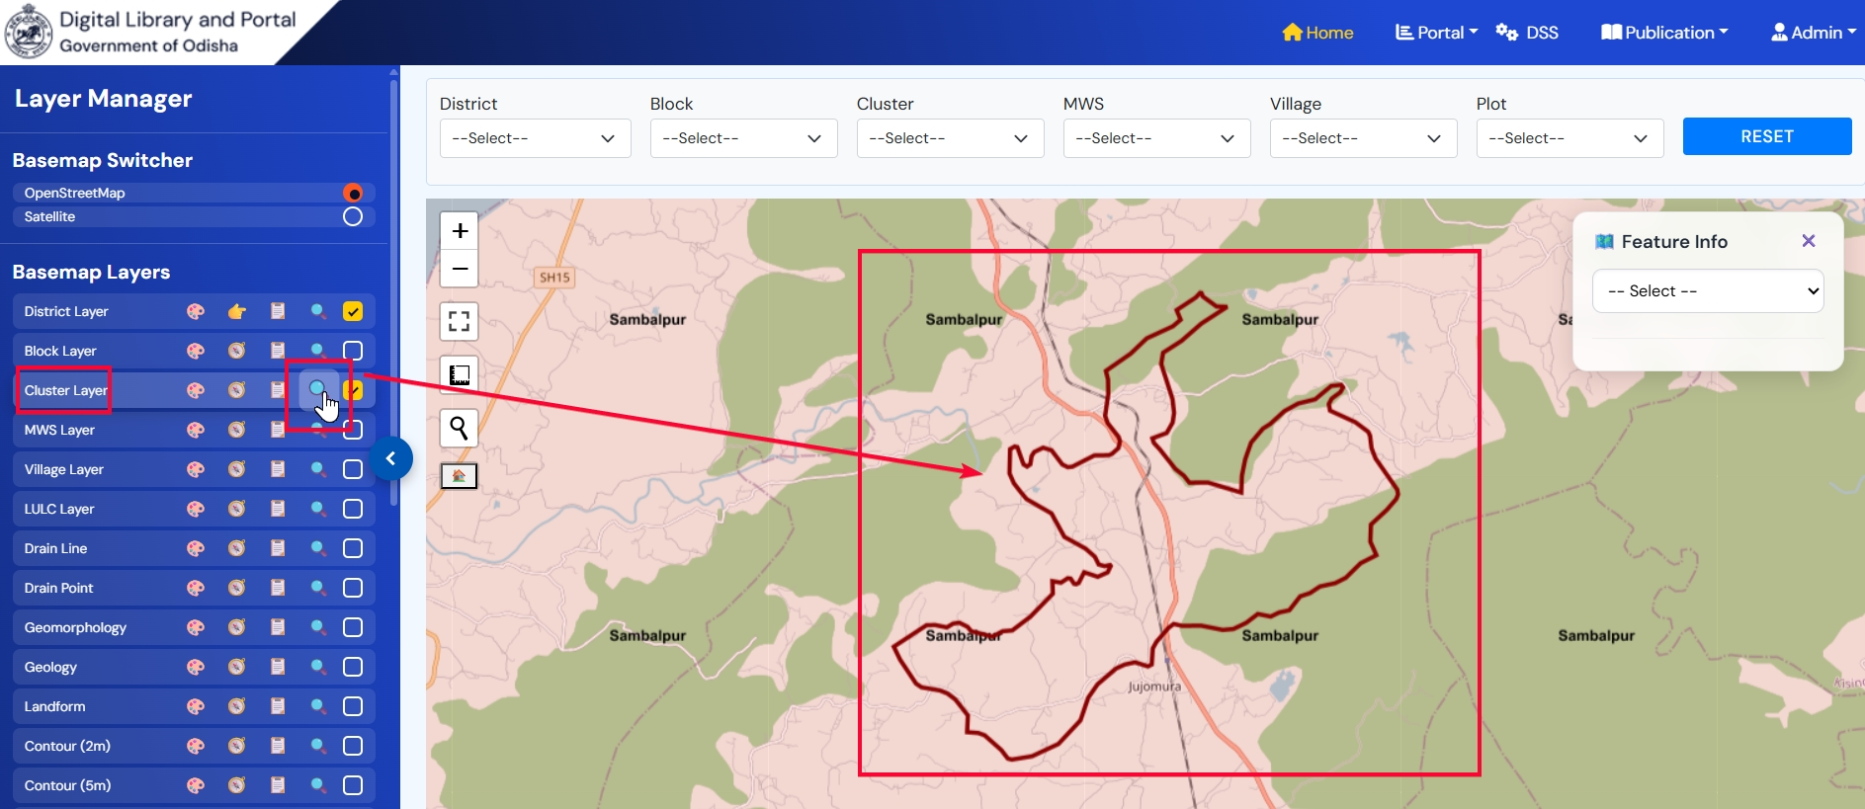
Figure 24: Zoom to Layer
- Click on ‘Zoom to start position’ to return to the default zoom set of the map.
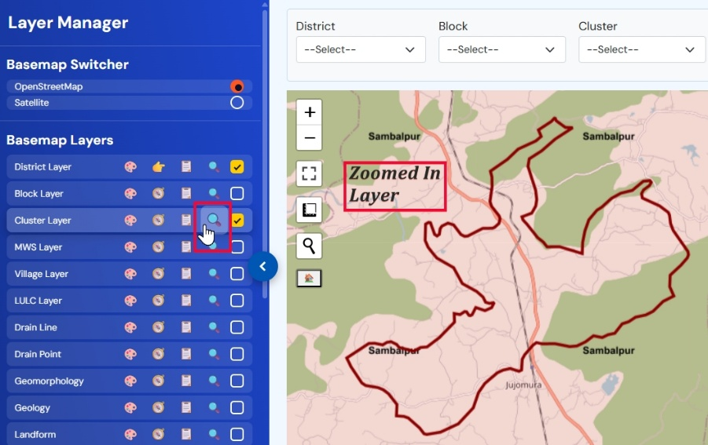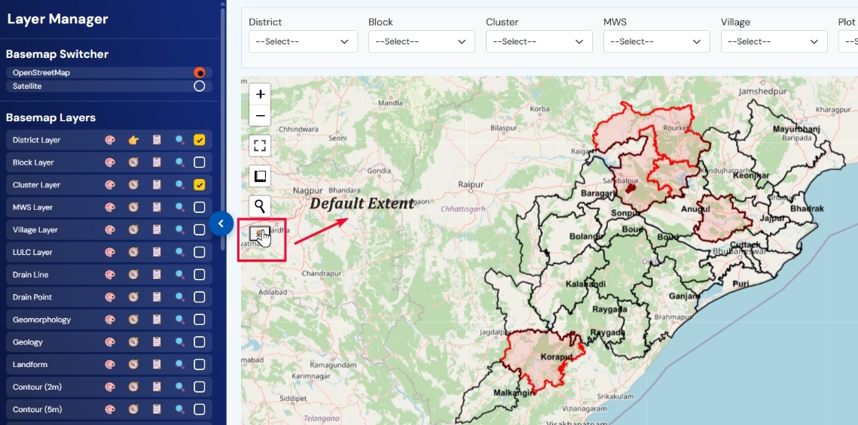
Figure 25: Default Extent

Style Manager
To change the color and width of any layer:
- Click on ‘Style’ tool for any layer.
- Application will open style manager window with ‘Style by Attribute’ checkbox with color editor for the layer.
- And with ‘Default Preview’ , ‘Preview’ and ‘Apply’ button.
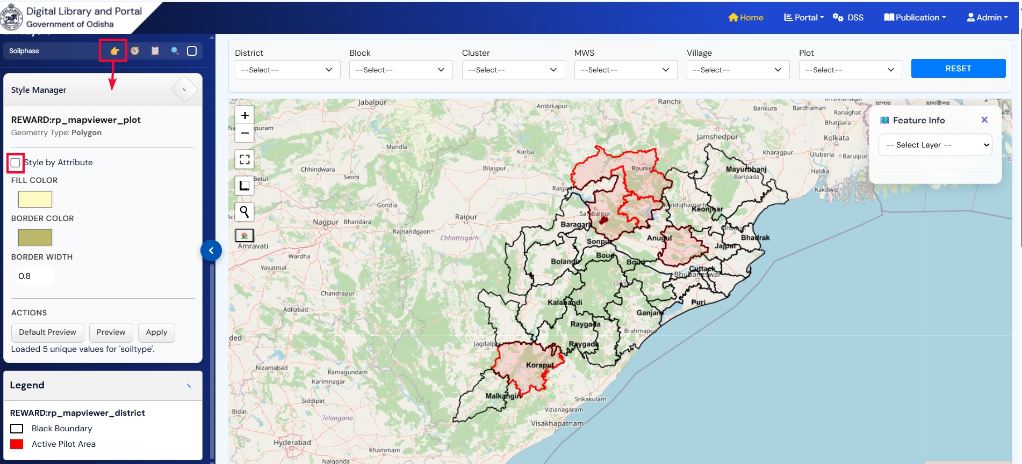
Figure 26: Style by attribute
- Click on ‘Style by Attribute’ checkbox and select any class from the dropdown, application will load all the attributes for the classes along with color editor.
- Click on ‘Load Classes’ button.

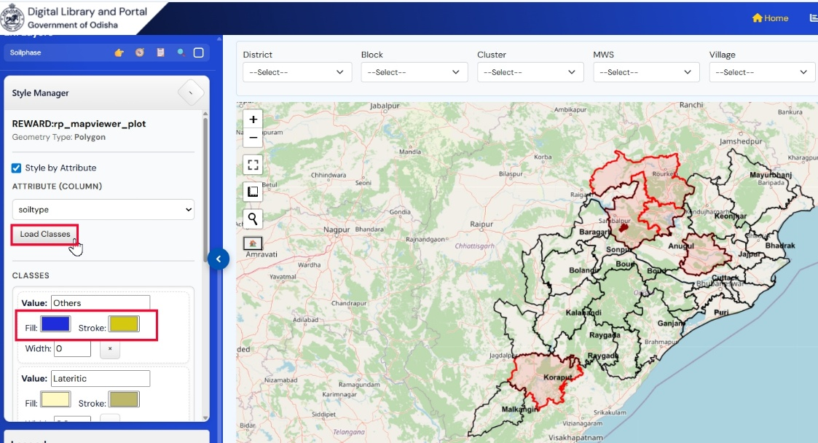
Figure 27: Choose Colour and change width
- Choose any color for the attributes and click on ‘Apply’ button to apply the changes.
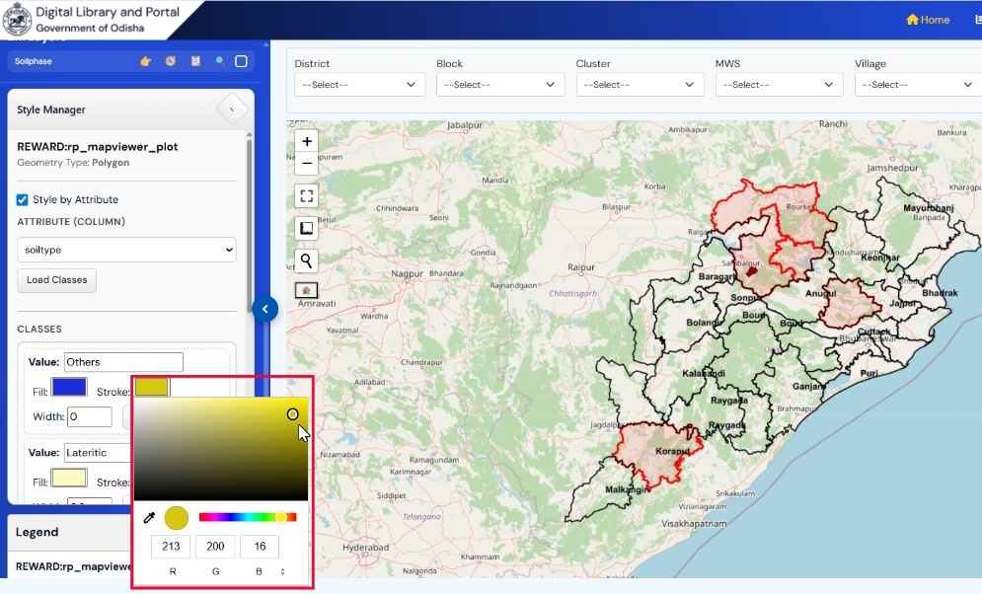
Figure 28: Choose Colour
- Click on ‘Preview’ to apply the changes temporarily.
- Click on ‘Default Preview’ to set the previous setting of style.
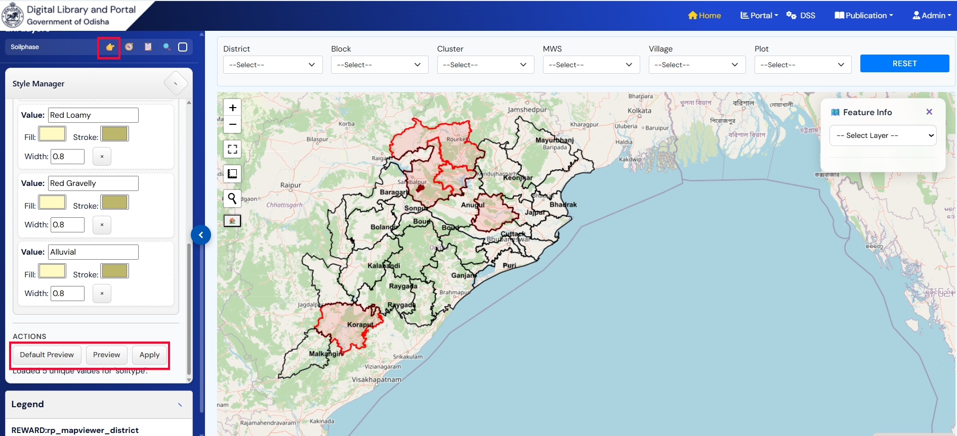
Figure 29: Apply Changes

Measurement Tool
To measure the area:

- Hover the Measurement Tool from the map and click on ‘Create a new measurement’.
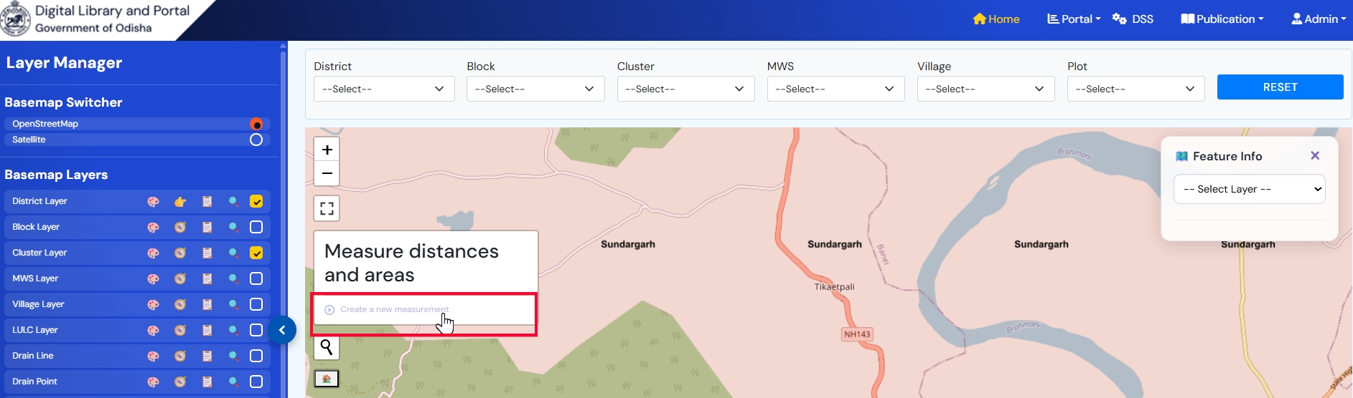
Figure 30: Create a measurement
- Click on the map to start drawing the polygon.
- Continue clicking to mark each corner of the area you want to measure.
- Click on ‘Finish Measurement’ to close the polygon and complete the shape.
- Once closed, user can view the measurement details.
- Click on ‘Delete’ button form the info pop-up to delete the polygon and user can measure again.
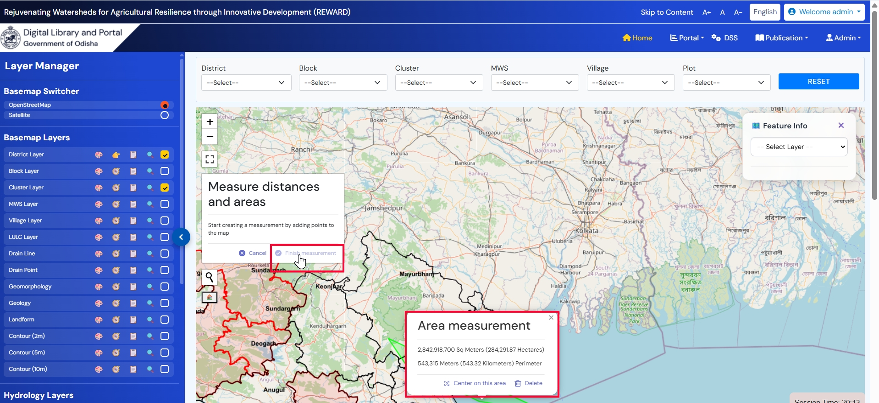
Figure 31: View Measurement

Search Location
To search location on map:
- Click on the ‘Search’ tool on the map.
- Enter the name of the place and click on ‘Enter’.
- Application will take the user to the entered location on the map.
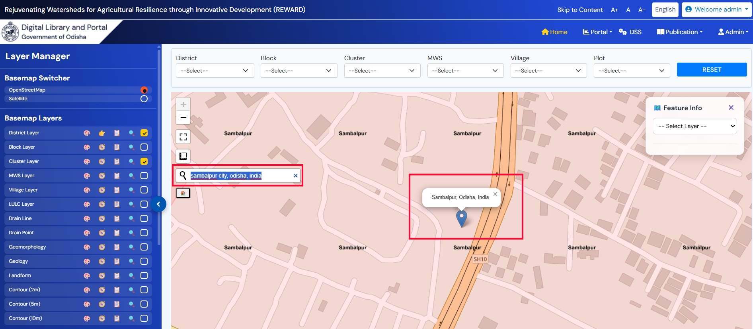
Figure 32: Search Location

Full Screen
- Click on the ‘Full Screen’ tool on the map.
- Click on ‘ESC’ from keyboard to return to default view.
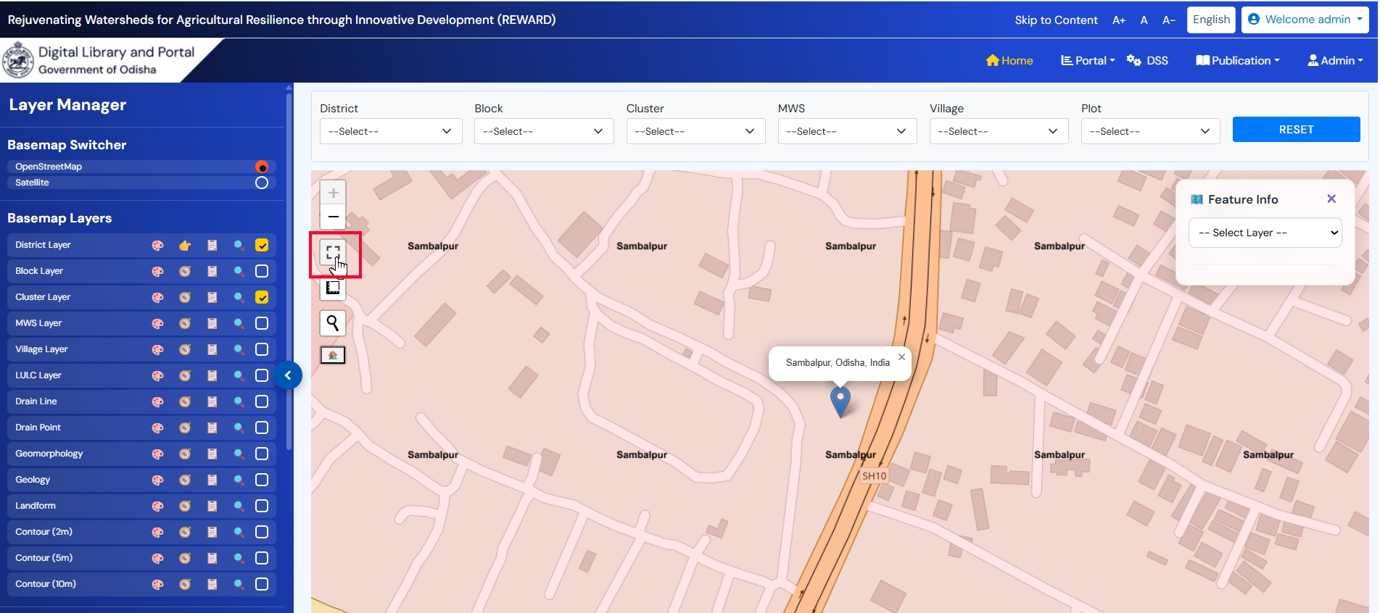
Figure 33: Full Screen

Dashboard
(Public User)

COMING SOON

